**I NEED HELP WITH ANNOTATIONS!!!**

**[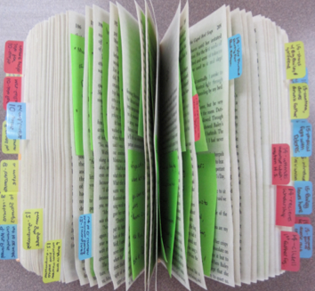](http://catlintucker.com/wp-content/uploads/2013/04/Screen-shot-2013-04-09-at-9.20.57-AM2.png)Highlighting tips:**

* Important passages
* Names of people
* Unfamiliar vocabulary
* Quotable lines
* Key research, statistics & facts
* Themes & main ideas

**Annotation shorthand:**

* ? = question or unsure of meaning
* * = important
* [ ] = quotable
* # = info, statistic or research
* ___= new vocabulary

**Making notes in the margin:**

* Write definitions
* Ask questions
* Translate ideas into your own words
* Make connections…other books, classes, life experiences
* Capture emotional reactions
* Summarize
* Comment on ideas
* Predict what will happen